7. razred
Dana 17. ožujka u cijelom se svijetu slavi Dan sv. Patrika. Pročitaj tekst i saznaj nešto više o običajima u Irskoj na Dan sv. Patrika te zatim riješi zadatke ispod teksta.

Saint Patrick's Day 2020
Haigh to all!
I'm Molly from Galway, Ireland. Last time you asked me to post something about Saint Patrick’s Day traditions. Unfortunately, this year some of them won’t be possible.
1 Wear something green
Did you know that wearing green makes you invisible to leprechauns? They will pinch you if you aren’t wearing something green. Ha, ha! When it comes down to which shade of green to choose, always go for shamrock green. However, don’t worry about it a lot. Mint, grass, olive, emerald or neon - it doesn't matter as long as you have a good time.

3 Have some corned beef and cabbage
Traditional Saint Patrick’s Day food is corned beef, cabbage, potatoes and soda bread. However, I don’t know anyone who follows this tradition, including myself. It does seem tasty, though.

2 Go to a parade
If you want to experience the spirit of Saint Patrick’s Day, going to a parade is a must. It’s so much fun. There’s music and dancing everywhere, people wear crazy costumes and dance on colourful floats. I feel sad to miss it this year but there’s always next year.
Molly's blog

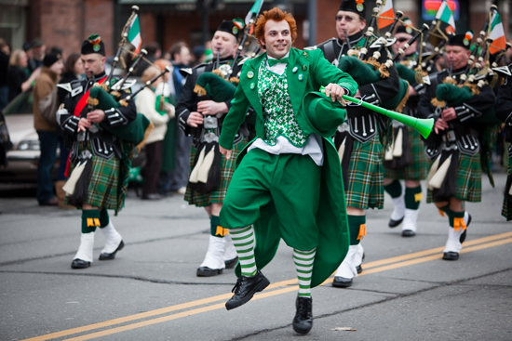

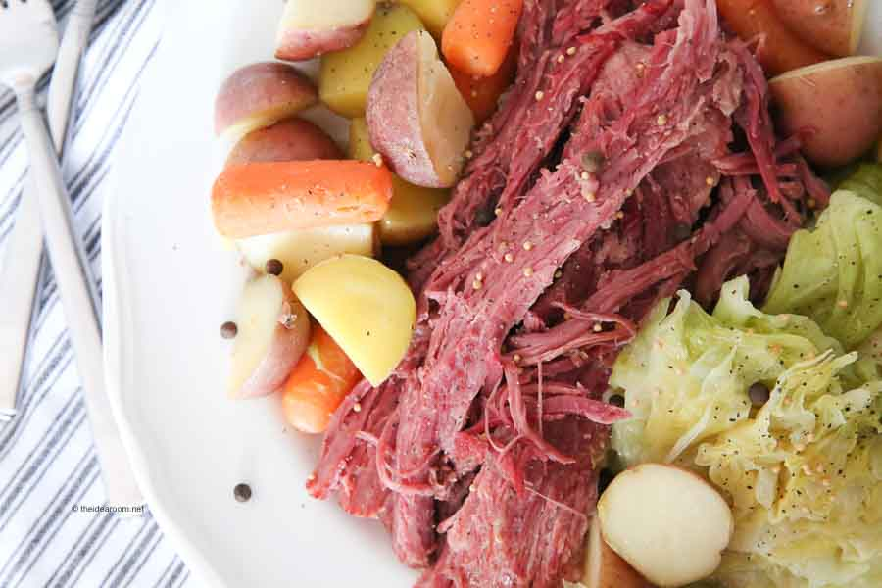

4 Do some St Paddy’s arts and crafts
There’s no better time to feel creative than on Saint Patrick’s Day, or St Paddy’s, as we call it. Do some face painting and draw a shamrock on your cheek. Make paper cut-outs in the shape of a shamrock or leprechaun’s hat. It’s all up to you.

5 See a landmark coloured green
Saint Patrick’s Day is celebrated all around the world by Irish and non-Irish people. It’s no wonder since Irish people used to be very poor and had to move to other countries, especially the USA. Therefore, some famous landmarks like the Empire State Building, Niagara Falls and the Sydney Opera House are lit green for this occasion.

+

1 Find the words in the text.
Pronađi riječ u tekstu i prepiši ju pored njenog značenja.
npr. a set of customs - tradition
1 unable to be seen –
2 a magical creature from Irish folk tales –
3 a public procession –
4 a large decorated vehicle used in festivals –
5 bread made with baking soda –
6 a three-leafed clover –
7 a building or a place that is easily recognized –
8 opposite of rich –

2 Are the sentences true or false? Write T (true) or F (false).
Jesu li rečenice točne ili netočne? Napiši T ili F.
1 You should wear something mint green on Saint Patrick's Day.
2 Molly thinks that green colour is magical.
3 There won’t be any parades this year because of the coronavirus.
4 Many Irish people don’t prepare the traditional Saint Patrick’s dish.
5 Saint Paddy’s Day is short for Saint Patrick’s Day.
6 There are many Irish people living outside of Ireland.
7 Only Irish people celebrate Saint Patrick’s Day.

3 Answer the questions in full sentences.
Odgovori na pitanja punom rečenicom.
1 Which Saint Patrick's Day traditions will be possible this year and which won’t?
2 How many shades of green are mentioned in the text? Go online and find five more.
4 Check your wardrobe. What would you wear for a Saint Patrick's Day party?
5 Would you like to try traditional Saint Patrick’s Day food? Why?
6 Go online and check the photos of landmarks mentioned in the text (while they are lit green). Which one is the most impressive?
7 Do people in Croatia celebrate Saint Patrick's Day? What do they do?

